Our vision
High quality careers education, information and guidance (CEIAG) is of huge importance to students, in all years, as they are prepared for the world outside of the school walls. We recognise the importance of this and it underpins our vision for CEIAG at Lincroft Academy. This strategy sets out a clear plan on how we intend to work towards meeting our vision in the short and longer term and should be read in conjunction with the Meridian ‘Careers Education, Information and Guidance’ procedures document that can be found at:
Meridian-Trust-Careers-Education-Information-Advice-and-Guidance-procedures-2025.pdf
Objectives
• To deliver high quality careers education that exceeds the provision required for the 8 benchmarks for good career guidance as identified by the Gatsby Foundation
• To work towards submitting a successful application for the ‘Quality in Careers Standard’ accreditation, the nationally recognised award for CEIAG in English Secondary Schools
• To become recognised as a leading school in CEIAG in the Bedford area
Introduction
Lincroft has a statutory responsibility for securing access to CEIAG for all pupils in years 8-11. We feel strongly that this should be extended to year 7. The purpose of the CEIAG is intended to assist pupils to make and implement education, training and occupation choices and to learn how to prepare for the workplace and their careers.
Careers guidance must include information on all 16-18 education or training options, including Apprenticeships and T-Levels. Most people spend many years of their life in a working environment and it is important to equip our students with the necessary skills for them to career plan and know how and where to access impartial and unbiased information.
Lincroft Academy has strong links with outside agencies and is working to foster further links with universities and colleges and local businesses which contribute to:
• Raising aspirations and increasing motivation – helping young people to identify educational and occupational goals
• Demonstrating the relevance of the knowledge and the skills learnt in subjects to future opportunities in learning and working
• Developing the skills for effective learning – reviewing achievements, setting targets, planning and taking action
• Demonstrating the links between living, learning and earning
• Improving literacy – developing information and communication skills
• Improving progression
• Reducing NEET (not in Education, Employment or Training)
• Careers work also supports strategies for student’s personal and social development by:
✓Building self-confidence and self-reliance
✓ Promoting positive and informed attitudes to learning
✓ Promoting leadership, organisation, resilience and initiative
✓ Developing good communication skills
We have a well-developed and effective work experience program for year 10 students and 99% of students make progress into further education, employment or training. However, we are aware that there are areas where we can improve and that it is our moral imperative to do so.
Our strengths
We have a careers team who are passionate about delivering an outstanding CEIAG programme. The PLEDGES programme is well established and compliments many of the transferable workplace skills needed in the workplace. Our academic mentoring programme enables every student to be well known and 1:1 guidance given regularly. Each tutor has the responsibility to support their tutees with the career journey. We have numerous strengths in our provision that we are proud of.
Our work experience programme
We have a good database of employers and plan to continue building these networks to ensure students have meaningful, high quality experiences. As working practices have evolved post Covid, we have enabled a flexible approach and also introduced virtual work experience opportunities for some students.
We view the opportunity for students to have a meaningful experience of the workplace of paramount importance in raising their aspirations and giving them greater insight into what life is like school. To this end we are proud that we are one of the few schools in the area where we arrange work experience for the whole of our Year 10 over a week during their Summer term and will continue to do so. This work experience is vital in:
• Students spending an extended period of time in a setting unfamiliar to them
• Students gaining and developing skills such as team working, independence, using their initiative and improving their communication skills
• Helping clarify their choices for their Post 16 destinations.
External Partners
There are a range of external partners who work with Lincroft Academy, including NHS Bedford, Army Careers, The University of Bedford, Bedford College Group, ASK apprenticeships, Form the Future, Speakers for Schools, SpringPod and Unifrog. The school’s careers strategy identifies that working with external providers is an important aspect of the programme and one which we will continue to strive to expand.
Gatsby Foundation 8 Benchmarks
The Gatsby Foundation was set up to work in areas that the trustees of the foundation are passionate about. One of these is Education and as part of that good careers guidance in schools. In 2013 the foundation commissioned Sir John Holman, a Professor of Chemistry at the University of York, senior education adviser and former headteacher, with setting out what career guidance in England would be like were it good by international standards. His report identified 8 benchmarks that schools should work towards to improve and deliver high quality CEIAG provision.

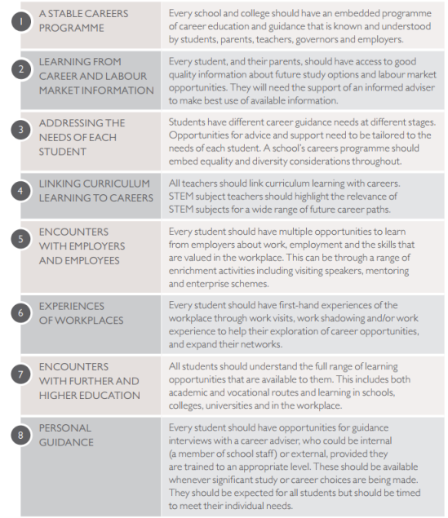

Current analysis against the Gatsby Foundation benchmarks The Gatsby Foundation provide a tool that allows us to see how the provision of CEIAG at Lincroft Academy compares against these benchmarks. Over the last few years our progress against meeting the benchmarks has been rapid.

 | All schools nationally | South East Midlands LEP | Lincroft June 2025
Benchmark 1 | 66% | 65% | 100%
Benchmark 2 | 81% | 81% | 100%
Benchmark 3 | 54% | 66% | 100%
Benchmark 4 | 76% | 78% | 100%
Benchmark 5 | 80% | 80% | 100%
Benchmark 6 | 64% | 68% | 100%
Benchmark 7 | 52% | 52% | 100%
Benchmark 8 | 75% | 71% | 100%

Our work now is focussed on developing the provision for each benchmark ensuring that our provision exceeds what is required.
Areas for further development
• Develop further the knowledge of the wider staff at Lincroft Academy around the Gatsby Benchmarks
• Develop Gatsby BM 4 further so that careers information is embedded in all subject areas across the school
• Consider how parental engagement with careers could be developed further, using the ‘Talking futures’ toolkit and actions from the Meridian trust CEIAG committee
• Enhance further the links with other education providers and the Local Authority
• Develop the use of Unifrog to track interactions and regularly upload these to Compass+ to track activities for all students
• Develop further the local employer, alumni and parent network so they, and their expertise, can form part of the careers provision and help influence our programme going forward
• More explicit promotion of post-16 options to students in Year 9 onwards, to include T-levels and apprenticeships

